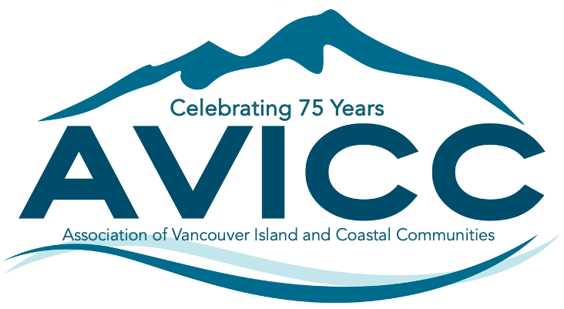 | AVICC 2024 Convention  April 12-14, 2024  Victoria Conference Centre  CALL FOR SESSION SUBMISSIONS
Thank you for your interest in participating in the 2024 AVICC Convention. It will be held Friday through Sunday, April 12-14, 2024, at the Victoria Conference Centre in downtown Victoria.

To submit a proposal, fill in the information requested below and email this document back as a word document to info@avicc.ca.

The deadline for submissions is Monday, December 4, 2023.

There are limited spots on the program including 45- to 60-minute plenary presentations, 60 minute concurrent workshops on Saturday afternoon, and two to three hour pre-convention workshops and study tours on Friday morning.

Delegates encourage sessions that involve multi-party perspectives (panels) and that are interactive, rather than “talking head” presentations. Topics should be relevant to our members, focusing on the important issues impacting elected officials and their communities.

Title of Session:

Name of Organization:

Contact Person Name:
Phone:
Address:

Email:
Session Description (for review of AVICC Executive Committee. This information will also be used in program materials):

Proposed Session Length:
Preferred Time and Day:
Audio Visual Requirements:

Travel or other expenses if any:

# of Proposed Presenters:

Name - Presenter #1:

Bio and Organization - Presenter #1:
Name - Presenter #2:
Bio and Organization - Presenter #2:

Name - Presenter #3:

Bio and Organization - Presenter #3:

Name - Presenter #4:
Bio and Organization - Presenter #4:

Any other Information or requirements:

Successful applicants must confirm their session description, session title, and final list of presenters with AVICC by January 31st, 2024 for inclusion in the brochure and program.

Changes to presenters or failure to meet this deadline may result in the session being cancelled.

Presenters agree to submit all PowerPoint presentations by March 29th, 2024.

I agree to the above conditions and deadlines:

Signature:
Name:
Date:

