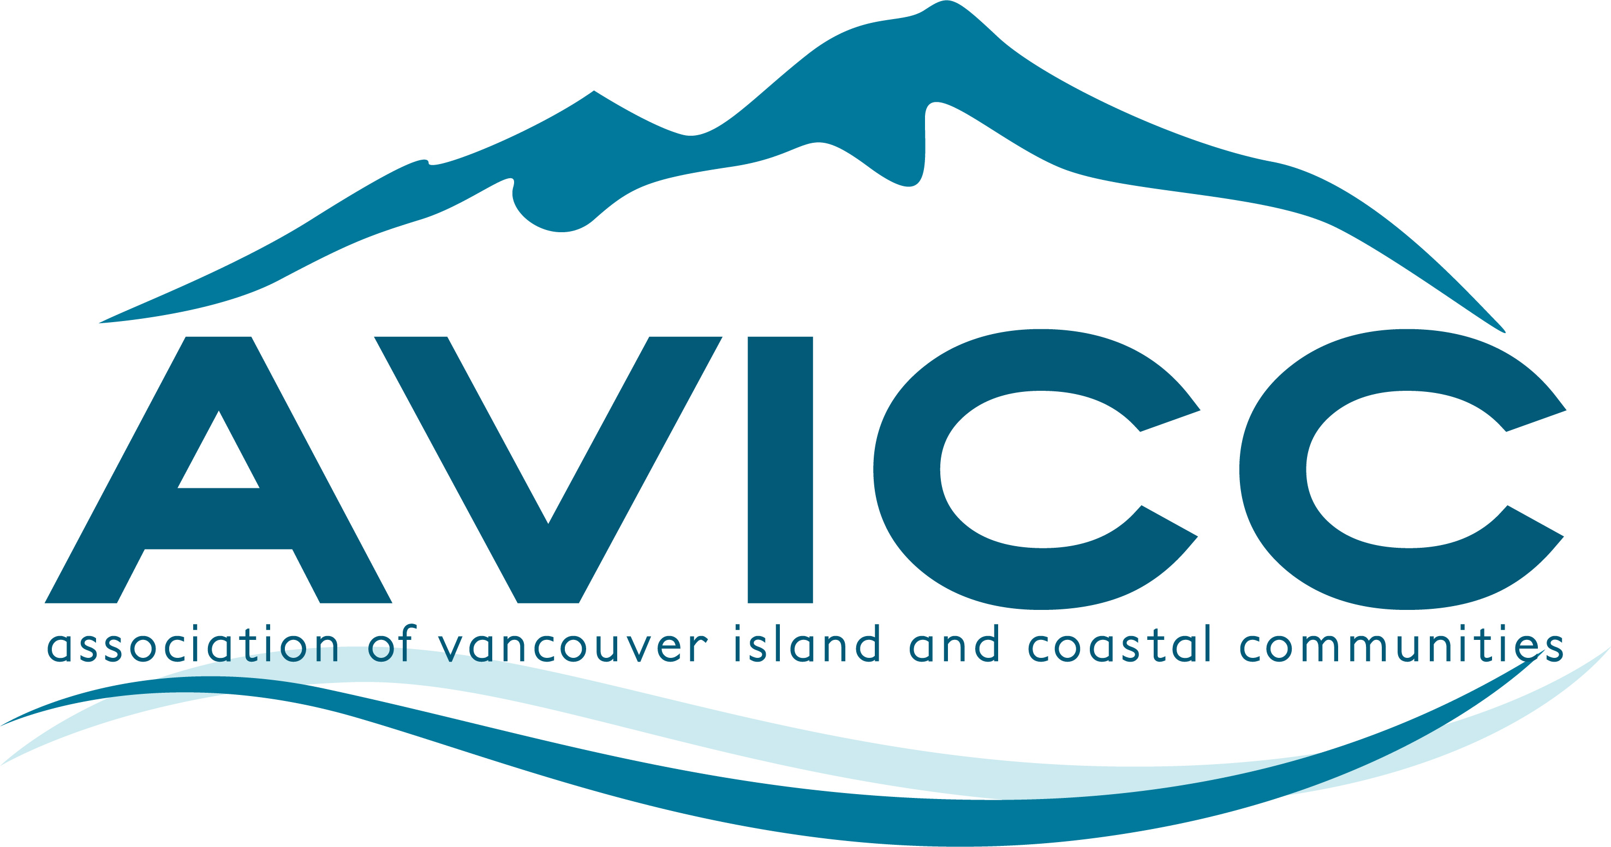 | AVICC 2025 Convention  April 11-13, 2025  Vancouver Island Conference Centre  CALL FOR SESSION SUBMISSIONS
Thank you for your interest in participating in the 2025 AVICC Convention. It will be held Friday through Sunday, April 11-13, 2025, at the Vancouver Island Conference Centre in downtown Nanaimo.

To submit a proposal, fill in the information requested below and email this document back as a word document to info@avicc.ca.

The deadline for submissions is Monday, December 2, 2024.

There are limited spots on the program including:
- three 60-minute plenary presentations;
- six 60-to-90-minute concurrent workshops on Saturday afternoon; and
- one 2-to-3-hour pre-convention workshop to take place on Friday morning.

Session Proposal Considerations:
- Delegates encourage sessions that involve multi-party perspectives (panels) and that are interactive, rather than “talking head” presentations.
- Preference will be given to sessions with an interactive or facilitated component to their proposal.
- Topics should be relevant to our local government members – focusing on the important issues impacting local government elected officials and their communities.

Please complete the following section with as much information as possible. The AVICC Executive will consider all of the proposed sessions at their December 13, 2024 meeting, with final decisions made at the January 17, 2025 meeting. Panelist information can be updated after the December 2nd deadline as sessions and details are confirmed.
Title of Session:

Name of Organization:

Contact Person Name:
Phone:
Address:
Email:
Session Description (for review of AVICC Executive Committee. This information will also be used in program materials):

Proposed Session Length:
Preferred Time and Day:
Audio Visual Requirements:

Travel or other expenses if any:

# of Proposed Presenters:

Name - Presenter #1:

Bio and Organization - Presenter #1:
Name - Presenter #2:
Bio and Organization - Presenter #2:

Name - Presenter #3:

Bio and Organization - Presenter #3:

Name - Presenter #4:
Bio and Organization - Presenter #4:

Any other Information or requirements:

Successful applicants must confirm their session description, session title, and final list of presenters with AVICC by January 31st, 2025 for inclusion in the brochure and program.

Changes to presenters or failure to meet this deadline may result in the session being cancelled.

Presenters agree to submit all PowerPoint presentations by March 28th, 2025.

I agree to the above conditions and deadlines:

Signature:
Name:
Date:

