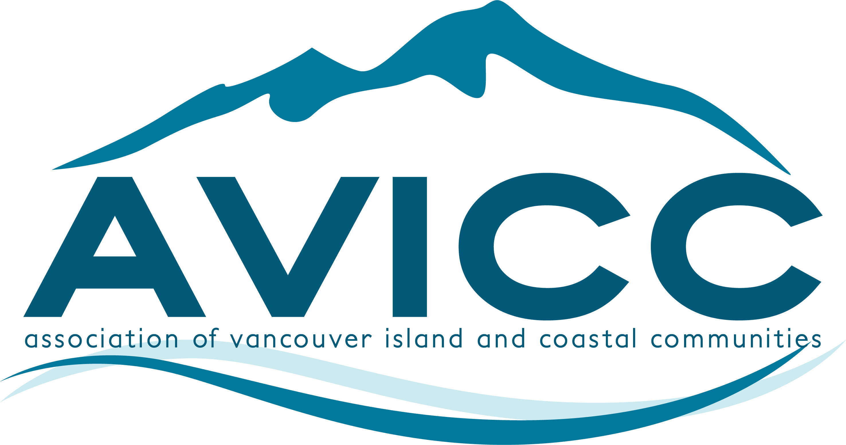 | AVICC 2026 Convention  April 24-26, 2026  Victoria Conference Centre  CALL FOR SESSION SUBMISSIONS

Thank you for your interest in participating in the 2026 AVICC Convention, being held Friday April 24, 2026 – Sunday April 26, 2026, at the Victoria Conference Centre, Victoria BC.

To submit a session proposal, please fill in the information requested on the following pages and email this document back as a word document to info@avicc.ca.

The deadline for submissions is Thursday, December 4, 2025.

There are limited spots on the program including:
- three 60-minute plenary presentations;
- six 60-to-90-minute concurrent workshops on Saturday afternoon; and
- one 2-to-3-hour pre-convention workshop to take place on Friday morning.

Session Proposal Considerations:
- Delegates prefer sessions that involve multi-party perspectives (panels) and that are interactive, rather than “talking head” presentations.
- Preference will be given to sessions with an interactive or facilitated component to their proposal.
- Topics should be relevant to our local government members – focusing on the important issues impacting local government elected officials and their communities.
- Successful applicants must confirm their session description, session title, and final list of presenters by January 31st, 2026 for inclusion in the brochure and program.
- Changes to presenters or failure to meet this deadline may result in the session being cancelled.
- Confirmed presenters agree to submit all PowerPoint presentations by April 9th, 2026.

Please complete the following section with as much information as possible. The AVICC Executive will consider all the proposed sessions at their December 12, 2025 meeting, with final decisions made at the January 24, 2026 meeting. Panelist information can be updated after the December 4th deadline as sessions and details are confirmed.

Title of Session:

Name of Organization:

Contact Person Name:
Phone:
Address:
Email:
Session Description

(for review of AVICC Executive Committee. This information will also be used in program materials):

Proposed Session Length:
Preferred Time and Day:
Audio Visual Requirements:

Travel or other expenses if any:

# of Proposed Presenters:

Name - Presenter #1:

Bio and Organization - Presenter #1:
Name - Presenter #2:
Bio and Organization - Presenter #2:

Name - Presenter #3:

Bio and Organization - Presenter #3:

Name - Presenter #4:
Bio and Organization - Presenter #4:

Any other Information or requirements:

- Successful applicants must confirm their session description, session title, and final list of presenters by January 31st, 2026 for inclusion in the brochure and program.
- Changes to presenters or failure to meet this deadline may result in the session being cancelled.
- Presenters agree to submit all PowerPoint presentations by April 9th, 2026

I agree to the above conditions and deadlines:

Signature:
Name:
Date:

