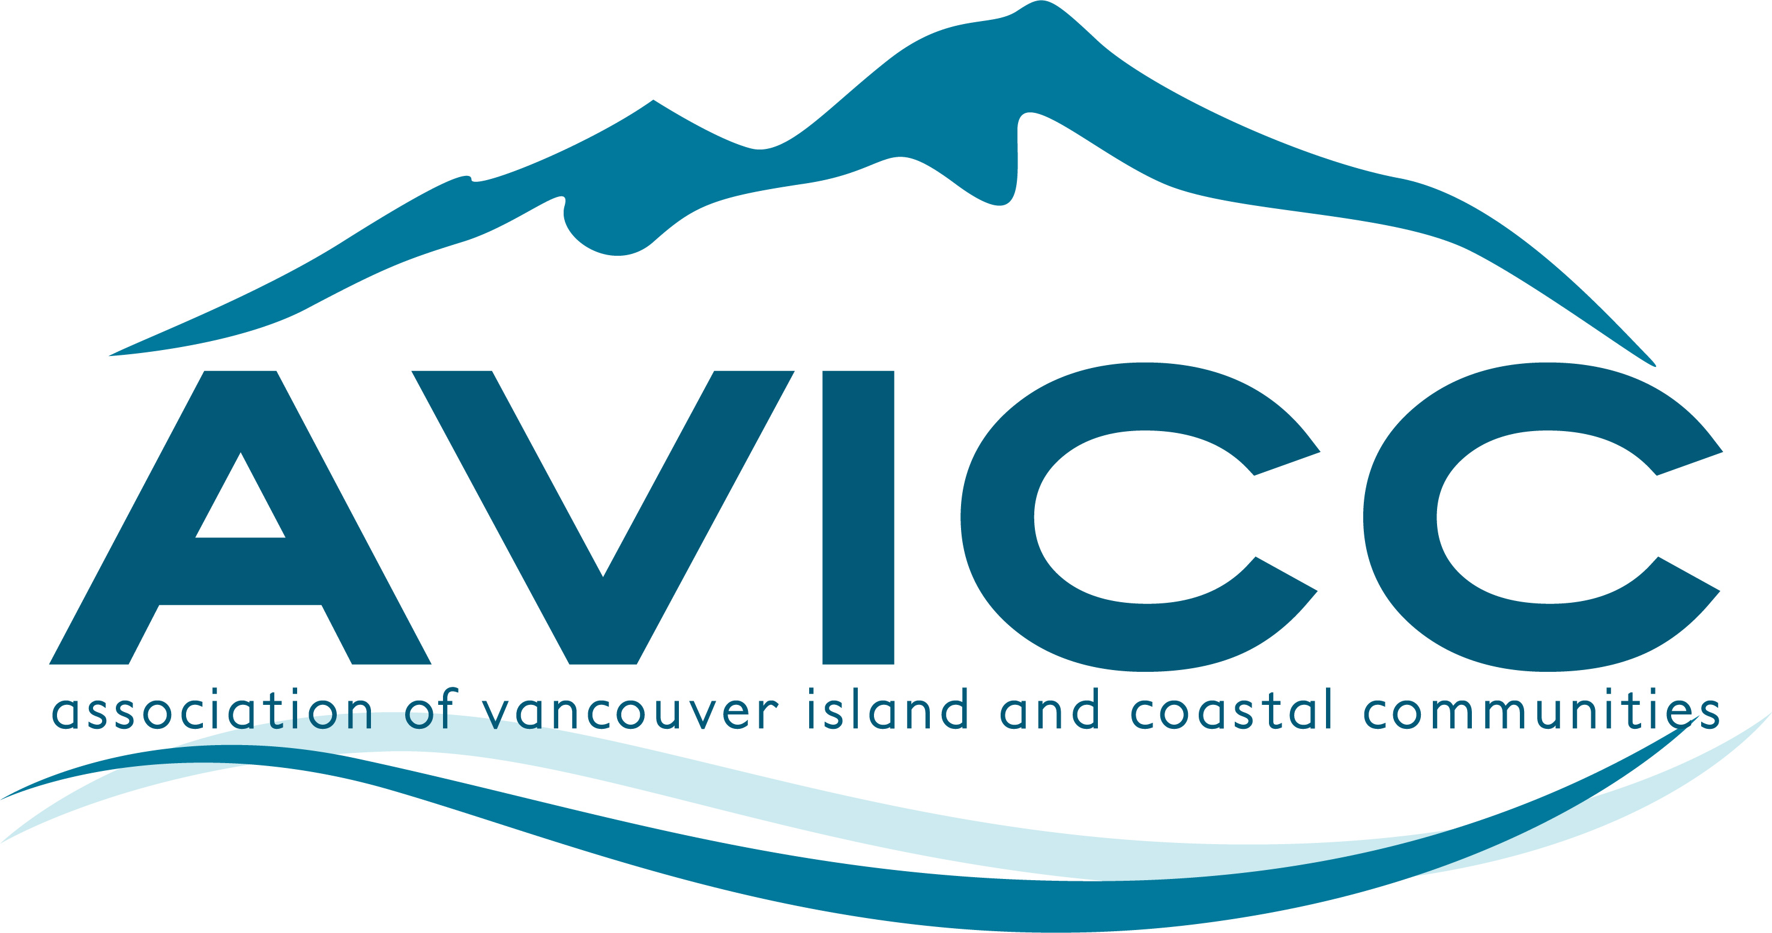 | AVICC 2027 AGM & CONVENTION  April 16-18, 2027 | Vancouver Island Conference Centre, Nanaimo  MEMBER SESSION RECOMMENDATION
SUBMISSION DEADLINE: FRIDAY, NOVEMBER 27, 2026 AT 12:00 NOON
Use this form to recommend a topic or speaker for consideration without submitting a fully developed session proposal. AVICC has one staff person, so member involvement in developing recommended sessions is strongly encouraged. Recommendations will be reviewed at the December 4, 2026 Executive meeting, with programming decisions finalized by January 2027.

Member organization name: | Member name and title:
Phone: | Email:
Title and/or topic:

Potential facilitators or panelists: Names or organizations, if known. Recommendations are encouraged even if potential facilitators or panelists have not yet been identified.

Session description: What would the session cover, and why would it be relevant to AVICC members?

Member involvement: Please indicate whether you can help develop the session, contact speakers, participate as a facilitator or panelist, or provide other support.

Additional information: Optional

Submit the completed Word document to info@avicc.ca by 12:00 noon on Friday, November 27, 2026.

